Web based Election Voting System

Software Requirements Specification

Version 1.0

10-07-2020

Sajjal Farooq (19010819-012)

Gulshan Fatima (19010819-013)

Nabeel Yousaf (19010819-021)

Laraib Mustafa (19010819-041)

Prepared for

CS-321—Software Engineering

Instructor: Mr. Zaheer Ahmed

Spring 2020

Contents

**1.** **Introduction:** 4

**1.1 Purpose** 4

**1.2 Scope** 4

**1.3 Definitions, Acronyms, and Abbreviations** 4

**1.4 References** 4

**2. General Description** 4

**2.1 Product Perspective** 5

**2.2 Product Functions** 5

**2.3 User Characteristics** 5

**2.4 General Constraints** 5

**3. Specific Requirements** 6

**3.1 External Interface Requirement** 6

**3.1.1 User interface** 6

**3.1.2 Hardware Interface** 6

**3.1.3** **Software Interface** 6

**3.1.4 Communication Interface** 6

**3.2 Functional Requirements** 6

**3.3** **Use Case** 6

**3.4 Classes/ Objects** 8

**3.3.1 Class Diagram:** 8

**3.5** **Non-Functional Requirements** 8

**3.5.1 Performance** 8

**3.5.2 Reliability** 8

**3.5.3 Availability** 8

**3.5.4 Security** 9

**3.5.5 Maintainability** 9

**3.5.6 Portability** 9

**3.6 Design Constraints** 9

**3.7 Logical Database Requirements** 9

**4. Analysis Model** 10

**4.1 Sequence Diagrams** 10

**4.1.1 Sequence Diagram of Administrators:** 10

**4.1.2 Sequence Diagram of Voter:** 11

**4.2 Data Flow Diagram (DFD)** 12

**4.2.1 Level 1** 12

**4.2.2 Level 2** 13

**5 Change Management Process** 13

A. Appendices 14

# **Introduction:**

This section gives a scope description and overview of everything included in this SRS document. Also, the purpose of this document is described and a list of abbreviations and definations is provided.

## **1.1 Purpose**

The purpose of this document is to make the functional and non-functional requirements of the

Election Voting System easy to comprehend. It also serves the purpose of making the functionality clear to end users.

## **1.2 Scope**

This SRS document applies to the initial version (release 1.0) of the “Online Election System” software package. This document describes the modeling and the requirement analysis of the system. The main aim of the system is to provide a set of protocols that allow voters to cast ballots while a group of authorities collect votes and output final results.

## **1.3 Definitions, Acronyms, and Abbreviations**

The following is a list of terms, acronyms and abbreviations used by the Online National Election Voting System software package and related documentation.

|  |  |
| --- | --- |
| **Abbreviations** | **Definition** |
| **OEV** | Online Election Voting |
| **EC** | Election Candidate |
| **ECA** | Election Commission Authority |
| **ESS** | Election Station Supervisor |
| **VIN** | Voter Identity Number |
| **DB** | Database |
| **VIC** | Voter Identity Card |

For the simplicity of documentation throughout the paper we have used masculinity for all genders.

## **1.4 References**

# **2. General Description**

The OEV is a web-based system so fundamental features related with web-based technologies such as client-server and database properties determine the software requirements of that project.

## **2.1 Product Perspective**

The software product is a standalone system and not a part of a larger system. The system will be made up of two parts. Before the election day the system will be used for general purposes such as viewing candidates’ profiles and past years’ election results. The voters will reach the system through web pages by using web-browsers such as Mozilla, Internet Explorer and Google Chrome. On the election day another independent system will be used for voting operations. This system will be adapted to the computers at the polling stations. The voters cast their votes using the interface that are provided at these machines. These votes are accepted by the system on the server. The ECA configures the whole system according to its needs on the server where the system is running.

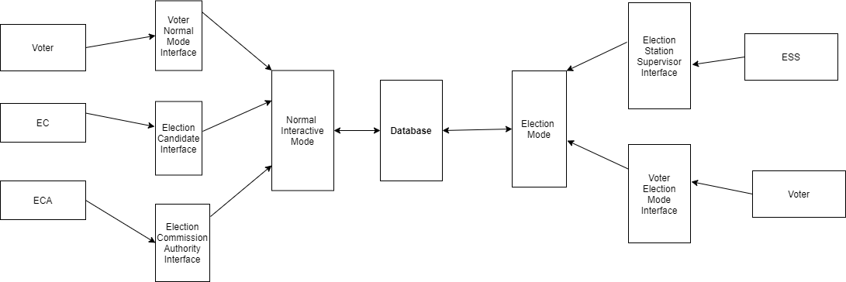

**Figure 1: Block diagram showing interaction between users and the system**

## **2.2 Product Functions**

The system can function in two modes, namely, Normal Interactive Mode and Election Mode. The system will be in Election Mode, for the purpose of vote polling only on the Election Day. Normal Interactive Mode is for accepting registrations, discussions between voters and candidates, campaigns and the system is available in this mode all the time except Election Days.

## **2.3 User Characteristics**

* Every user should be comfortable of working with computer and net browsing.
* Every user has to register.
* Every user should have their own login and password.
* Every user can send complain to admin.
* Every user must have basic knowledge of English too

## **2.4 General Constraints**

The development team must design, develop and test this software within the space of three months. They also have important limitations placed on their time due to many other projects that they must work on. They also suffer from server lack of funding. Due to these constraints, as well as the limited number of people working on the project, it may necessary to prioritize certain aspects of the project over others. Functionality and security will be the first priorities.

.

# **3. Specific Requirements**

## **3.1 External Interface Requirement**

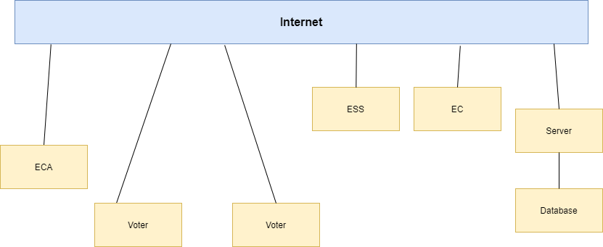

**Figure 2: Showing interface relations**

### **3.1.1 User interface**

The system must provide a user interface for all types of users (ECA, ESS, EC, and Voter) that is available through all Web browsers. The user interface for voter must be different for Election Mode and Normal Interactive Mode.

### **3.1.2 Hardware Interface**

There are no hardware interfaces to this software system. The only interfaces are through a computer system.

### **Software Interface**

The poll server runs on http server that is enabled to handle server pages. It uses a relational database to keep track of the polls, which it connects through standard database connectivity interfaces. In order to run the setup software, the environment needs to have a Java Virtual Machine running on it.

### **3.1.4 Communication Interface**

* A router connected through an internet
* Communication interfaces include HTTP server hosted.

## **3.2 Functional Requirements**

## **Use Case**

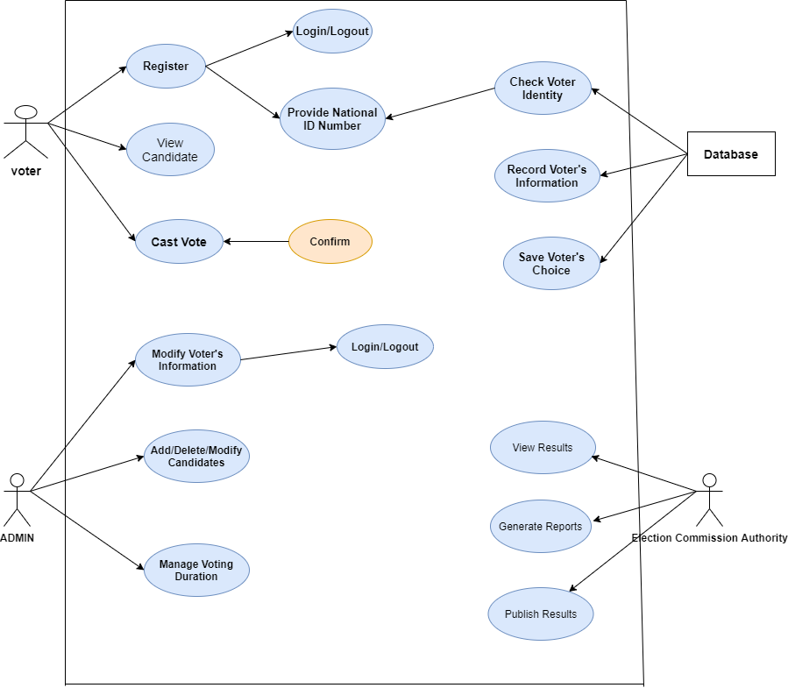

**Figure 3: Use Case Diagram of Online Voting System**

## **3.4 Classes/ Objects**

### **3.4.1 Class Diagram:**

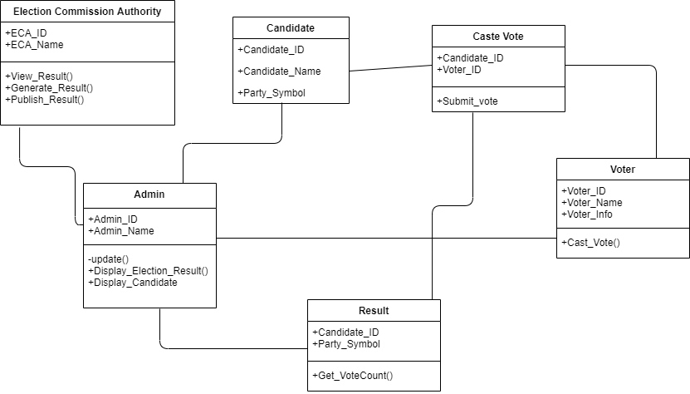

**Figure 4: Class Diagram of Online Voting System**

## **Non-Functional Requirements**

### **3.5.1 Performance**

The system is expected to have reasonable short time response. The voter should be able to login and should be able to get response for his requests in 2-3 seconds.

* **In Election Mode:** The system is expected to serve a maximum of up to 50000 voters instantly, each voter being active for at most 5 minutes requesting up to 5 pages. This shows that the system should be able to handle about 2000 transactions each second. In addition, the system must be working at 100% peak efficiency during the voting process.
* **In Normal Interactive Mode:** The system in this mode is expected to serve maximum of up to 50000 voters, but each voter can be active for a long time.

### **3.5.2 Reliability**

* **In election Mode:** The system should be 99% reliable.
* **In Normal Interactive Mode:** Since it may need some maintenance or preparation for the Election Day, the system does not need to be reliable every time. So, 80% reliability is enough.

### **3.5.3 Availability**

* The system should be up and running whenever needed.

### **3.5.4 Security**

* The data transaction between client and server must be encrypted using SSL technology.
* All the passwords that are generated or accepted must be stored in database in an encrypted form.
* To prevent attacks the system should generate random word and ask the user to enter it correctly for multiple tryings.
* In election mode, the different password should be generated for a TCK in every different election.

### **3.5.5 Maintainability**

The system will be well documented and it will be designed to be modular. The use of Web programming will also help to increase maintainability. This will make it easier for future developers to make changes and updates to the system with a minimal amount of effort.

### **3.5.6 Portability**

The system should be able to work with other existing systems. It should ensure backward and forward compatibility.

## **3.6 Design Constraints**

**OEV** is a user-friendly system that contain a simple design.

## **3.7 Logical Database Requirements**

1. **Voter:**

|  |  |
| --- | --- |
| **Attribute Name** | **Attribute type** |
| Voter_ID | Int |
| Name | Char |
| Age | Int |

1. **ECA:**

|  |  |
| --- | --- |
| **Attribute Name** | **Attribute Type** |
| ECA_ID | Int |
| Name | char |

1. **Admin:**

|  |  |
| --- | --- |
| **Attribute Name** | **Attribute type** |
| login | Int |
| logout | int |

# **4. Analysis Model**

## **4.1 Sequence Diagrams**

### **4.1.1 Sequence Diagram of Administrators:**



**Figure 5: Sequence Diagram for Administrator (Electoral Commission Authority)**

### **4.1.2 Sequence Diagram of Voter:**



**Figure 5: Sequence Diagram for Voter**

## **4.2 Data Flow Diagram (DFD)**

### **4.2.1 Level 1**



### **4.2.2 Level 2**



# **5 Change Management Process**

Change Management Processes include a sequence of steps or activities that move a change from inception to delivery.

1. Step 1: Urgency Creation. A change is only successful if the whole company really wants it. ...

2. Step 2: Build a Team. ...

3. Step 3: Create a Vision. ...

4. Step 4: Communication of Vision. ...

5. Step 5: Removing Obstacles. ...

6. Step 6: Go for Quick Wins. ...

7. Step 7: Let the Change Mature. ...

8. Step 8: Integrate the Change

# Appendices

**1 Glossary**

**ASCII:** a standard 7-bit code for representing characters—letters, digits, punctuation marks and control instructions---with binary values, the code values ranging from 1 to127.

**Voter:** a voter who is on the enumerate list and who has been given the authority to cast vote.

**Ballot:** a means of registering a vote.

**Database:** any aggregation data, Files consisting of records, each of which is constructed of fields of a particular type, together with a collection of operations.

**A.1**

* To develop an online web-based voting system that can be used during the election period to vote.
* To come up with a system documentation.
* To establish the metrics for measuring and evaluating.
* To establish the principles that support usability.

**A.2**

Our mission is **“Providing the Knowledge on the Future of Voting”.**

Our goal is to support the implementation of modern election processes and technologies with the view of facilitating elections and increasing security and transparency. Voting technologies have the potential to improve elections and to increase voter turnout since remote voters and voters with disabilities are enabled to vote.

We are convinced that voting technologies are the future of voting. We support election administrations and organizers as well as technology vendors in developing and implementing technology and tackling the challenges to enable a successful application.

**A.3**

We are only four employees that work hardly on this project.

**A.4**

Our project is computerized.

**A.5**

We use WAMP server and visual code to make our project.

**A.6**